YCDC e-Service
REGISTER MANUAL

FOR ARCHITECTS, CIVIL ENGINEERS (Construction)
& LAND OWNER

https://ybps.ycdc.gov.mm/

Table of Contents
1. Introduction 3
2. Accessing e-Service 3
3. Registering for an Account 5

1. Introduction
The system is built to support the following functions specific to the administration of development proposals:
- Registration of architects, civil engineer (construction) and land owner into the system – architects, civil engineer (construction) and land owner can register themselves into the system and vetting is done by the appropriate institution in order to permit them to access the system’s functionality.
- Submission of Development proposals for review and approval – architects, civil engineer (construction) and land owner can upload their Development Proposals online without having to present themselves physically at the County offices.
- Monitoring of submitted Development proposals – Applicants can log into the system and view the status of their submitted building proposals. The system also notifies the Applicants/Owners/Developers via SMS and email once the proposals complete key milestones in the system. Notifications are also received when actions are pending for the applicant e.g. requests to make payment.

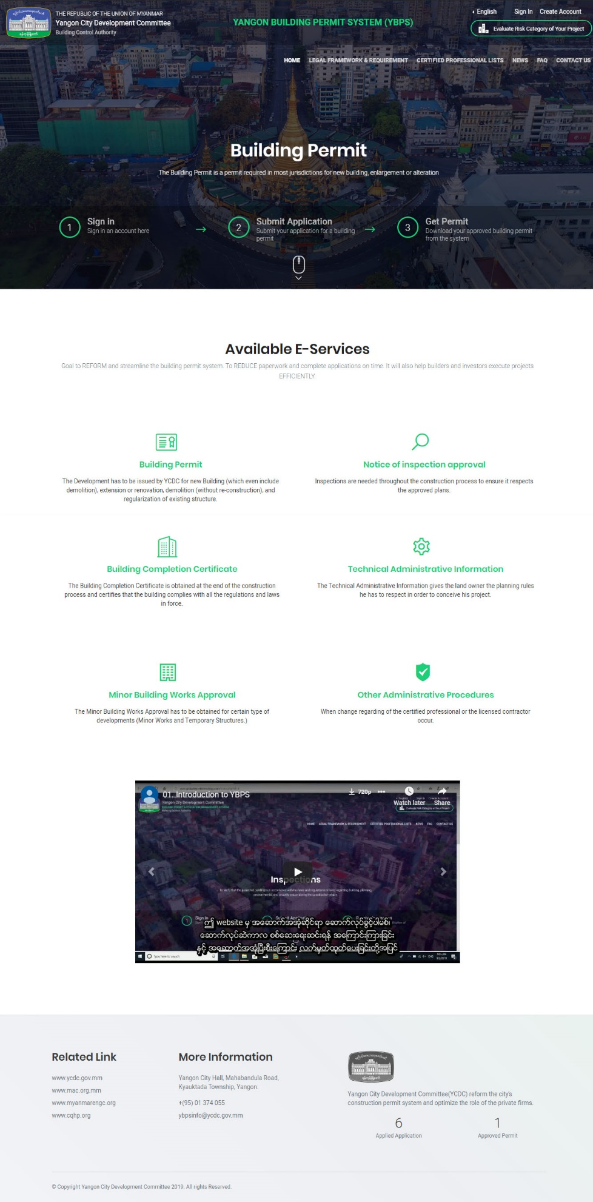

2. Registering for an Account
Registered Architects, Civil Engineer & Land Owner are allowed to register and submit development proposals on e-Service.
To register for an account, click on Create Account button at the top right corner of the website. A form to fill out account details will be shown as below. For Example
- Full Name as User’s Name
- User Name as User’s Name
- Email and Confirmed Email as User’s email address
- Password as you like (Minimum of 6 characters)
- Mobile Number as User’s mobile number
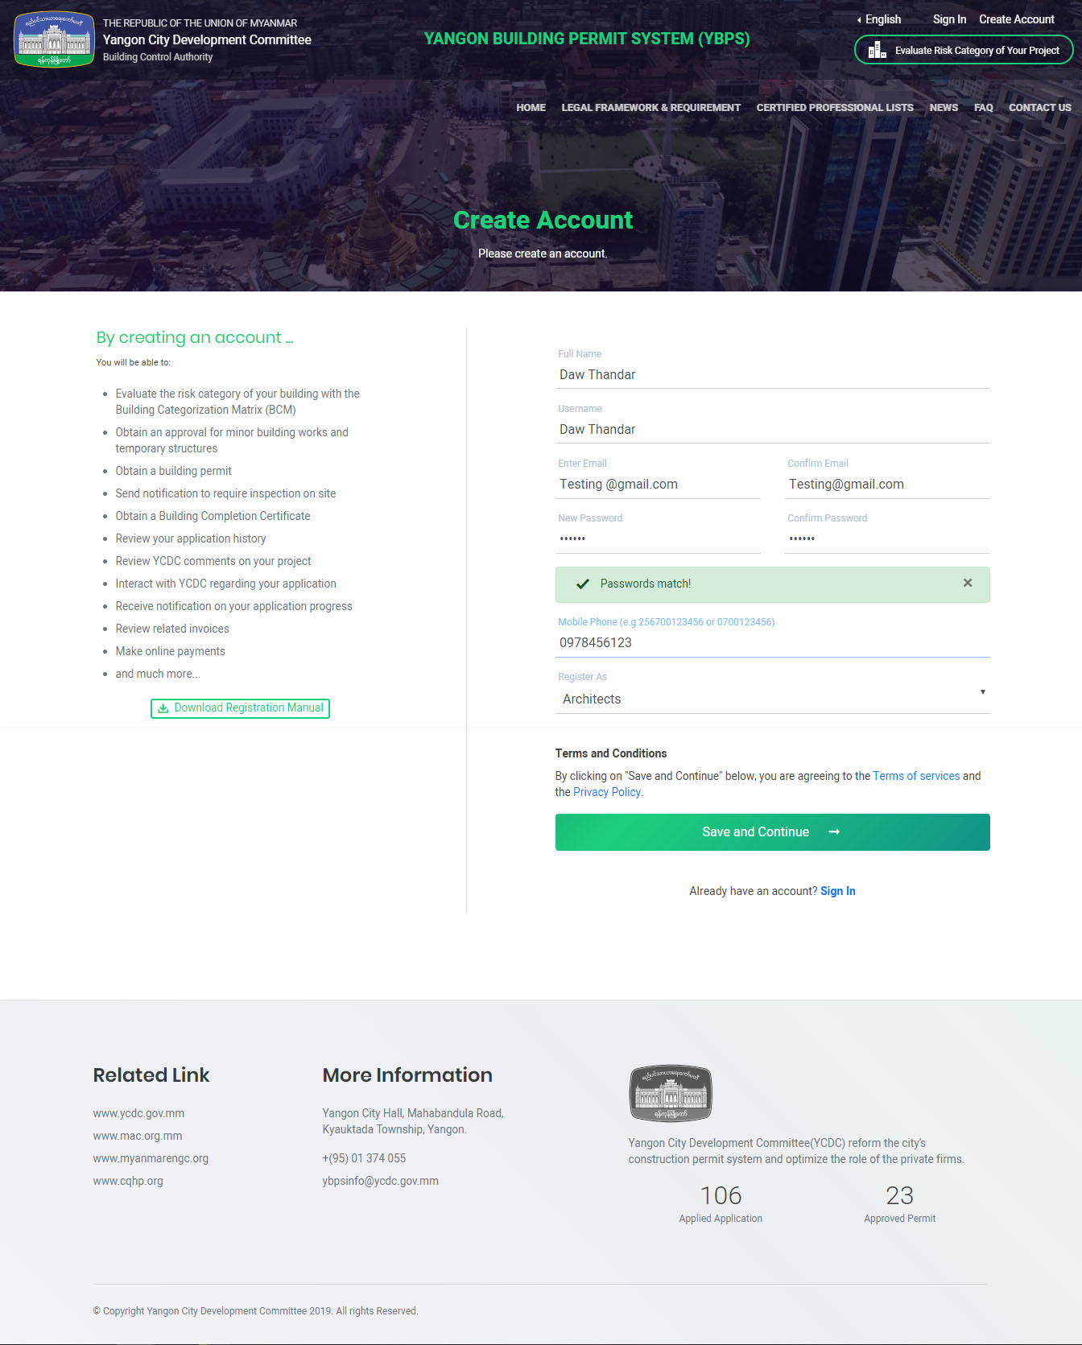
- Choose Register type from given rolls (Architects, Civil Engineer or Land Owner). After fill out, click Save and Continue button.

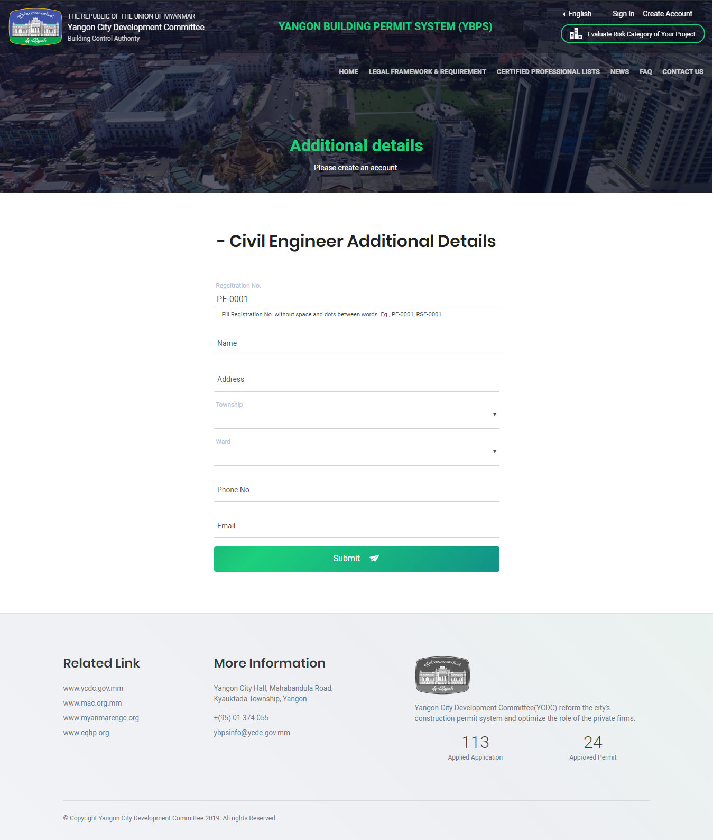
If you registered as Land Owner, additional information does not need to fill up. Otherwise registered as Architects or Civil Engineer, need to fill in professional’s additional information. After fill up additional information, click Submit.
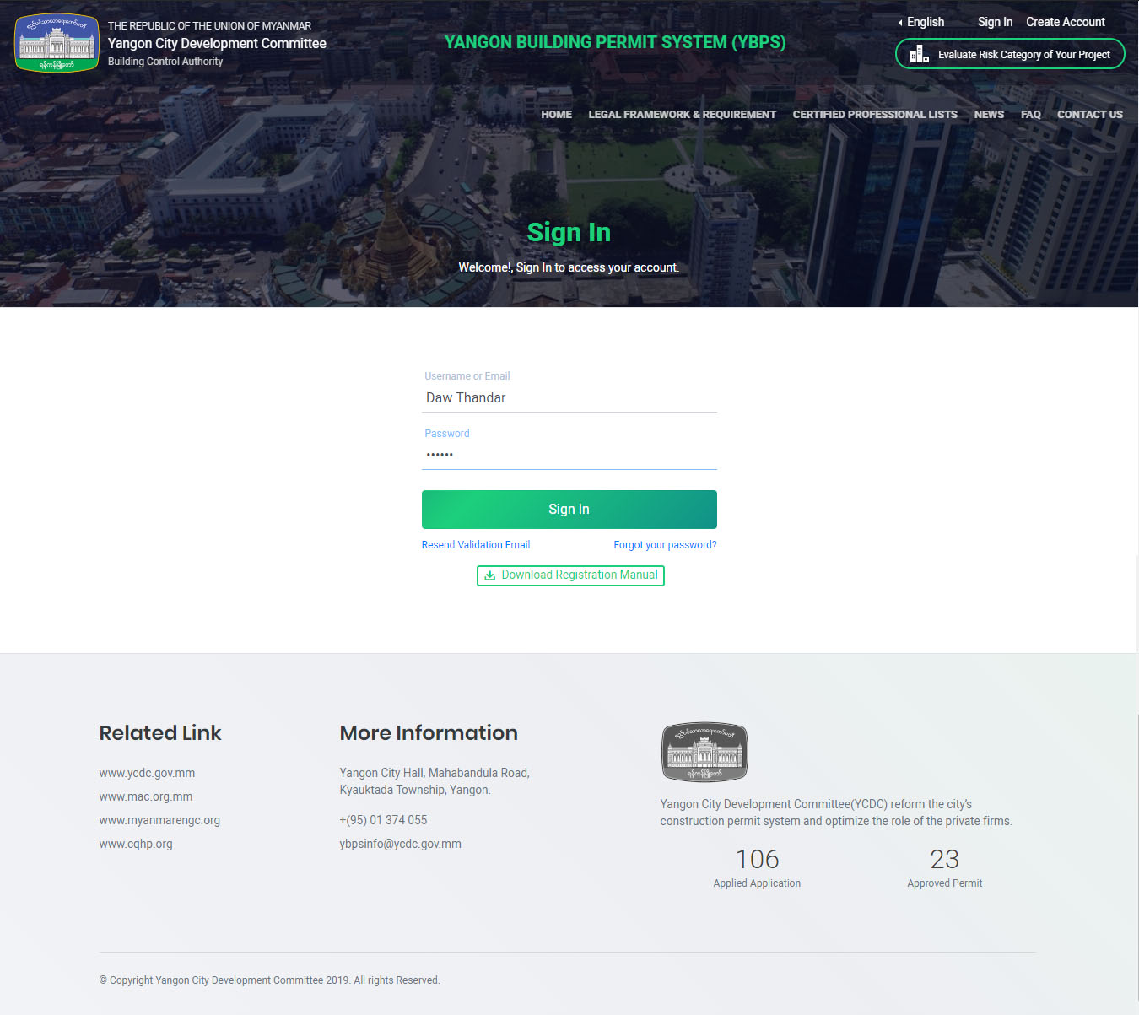
A confirmation mail to activate your account will be sent to the email address that you provided in this registration form. If you register as Land Owner, you will receive one email. If you registered as Architects or Civil Engineer, you will receive two emails. You will success registering by clicking the link from email that you received.

